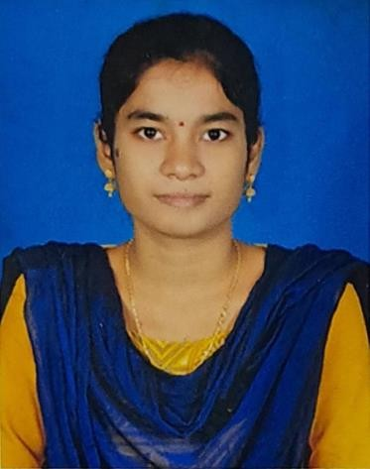 **CURRICULUM VITAE**

Name : MAMIDI PRASANTHI

**Designation** : **Lecturer** in Chemistry

**Address :**Government Degree College

Palakonda, Parvathipuram Manyam Dist.

Andhra Pradesh, India

**Mobile No :** 9515453455

**E-Mail Id :** [prasanthimamidi95@gmail.com](mailto:prasanthimamidi95@gmail.com)

**Date of Birth :** 10-06-1995

Qualification : M. Sc., B.Ed.,APSET

Date of Joining. :09-12-2020

Prior to Govt. Service : 2 years

Address (Res) : Mamidivalasa (Village &post)

Burja Mandal, Srikakulam District,

Pin :532445 ,Andhra Pradesh.

**Academic Qualifications :** M.Sc.,(Chemistry) , B.Ed.

Specialization. : Physical Chemistry

|  |  |  |  |  |
| --- | --- | --- | --- | --- |
| **Qualification** | **University/Board** | **Year of Passing** | **% of**  **marks** | **Class**  **Secured** |
| **M.Sc,(Chemist ry)** | Andhra university, | 2017 | 8.03 | 1st class with Distinction |
| **B.Ed.,** | Dr.B.R.Ambedkar University, Etcherla. | 2022 | 8.52 | 1st class with Distinction |
| **AP SET** | Andhra University | 2019 | General Category | |

**Participation in academic conferences/seminars/workshops:**

* Participated in the 3-day Training Programme on “***Internship and LMS***” From 02.02.2023 to 04.02.2023 at Nodal Resource Center (NRC), SV Govt. Degree College, Parvathipurm, oraganized by CCE, A.P., Mangalagiri.
* Participated in the 6-day Training of the Trainers Programme on “**English medium of Instruction, Proficiency in English**” From 12.06.2023 to 17.06.2023 at Nodal Resource Center (NRC), SV Govt. Degree College. Parvathipurm oraganized by CCE, A.P., Mangalagiri.

**Academic Activities involved:**

1. IQAC Criterian-5– Member

2. Science Association Committee – Member